## Declaration

I, [Student Name], declare that this assignment, titled [Assignment Title], is my own original work and has not been copied from any other source except where explicitly acknowledged. I have not engaged in plagiarism, collusion, or any other form of academic misconduct in the preparation and submission of this assignment. All sources of information and data used in this assignment have been properly cited and referenced in accordance with the prescribed guidelines. I have not used unauthorized assistance in the preparation of this assignment and have not allowed any other student to copy my work. I am aware that any breach of academic integrity may result in disciplinary action as per the [policies of Monash University](https://www.monash.edu/learning-teaching/priorities-and-programs/assessment-and-academic-integrity/assessments-and-integrity-policy-and-procedure), which may include failing this assignment or the course, and further academic penalties.

Signature: __________ Date: _____2025.7.4______________

## Github Check

Enter your Github details here.

|  |  |
| --- | --- |
| Github Username  *Enter your username here* | Skyeon-monash |
| **A2 Shared?**  *Have you started and shared your assignment repository with your tutor yet?* | Yes |

## Self-Evaluation

Rate your performance for each criteria. Put a ✅(tick) in the box where you think your work belongs.

|  |  |  |  |  |
| --- | --- | --- | --- | --- |
| **Criteria** | **Exceeds Expectations** | **Meets Expectations** | **Needs Improvement** | **Fail to meet expectations** |
| Executive Summary |  | ✅ |  |  |
| User Personas |  |  | ✅ |  |
| Sitemap |  | ✅ |  |  |
| Wireframes/Low-fidelity Prototype |  | ✅ |  |  |

## Section 1: Executive Summary

This project entails the development of a modern, responsive web application for a renowned health charity dedicated to improving the health and well-being of vulnerable populations, with a specific focus on elderly individuals. Many seniors face challenges such as limited mobility, social isolation, chronic health conditions, and difficulties navigating digital platforms. This web application aims to support elderly users by offering accessible, user-friendly, and reliable health services online.

The charity’s core objective is to leverage digital technology to expand its outreach, enhance service accessibility, and simplify service delivery for elderly users and their caregivers. The web application will serve as a digital gateway for accessing trusted health information, making support services more visible and easier to use.

Key functionalities will include appointment booking with calendar-based conflict management, interactive maps for locating nearby services, user ratings and reviews, and a simplified login and registration system with role-based authentication. Special attention will be given to accessibility, including large-text interfaces, keyboard navigation, and screen reader support to comply with WCAG 2.1 AA standards.

Developed using the VueJS 3 framework, the application will be fully responsive across desktops, tablets, and smartphones. It will include dynamic content loading from state-managed structures or APIs, interactive tables for searching and sorting health service data, and secure features such as external authentication and XSS protection.

Innovative features will further enhance the user experience, such as an admin dashboard for staff to monitor activity, bulk email notifications via SendGrid, data export to PDF/CSV, and integration with generative AI tools for interactive health Q&A or support.

By embracing technology that caters specifically to the needs of older adults, this web application will strengthen the charity’s mission to build a more inclusive, digitally connected health support system for the elderly population.

## Section 2: User Personas

### User Persona 1: Margaret Liu

Margaret Liu is a 72-year-old retired primary school teacher living alone in public housing in Melbourne, Australia. Although she has a deep sense of independence, her physical mobility has declined slightly in recent years. Her granddaughter occasionally helps her with digital devices, particularly her Android tablet, which she uses to browse the internet or read the news. While Margaret is intelligent and curious, she often struggles with navigating websites due to her declining eyesight and limited confidence in using unfamiliar applications.

Margaret’s main goals include maintaining her health, accessing trusted information about aging and wellness, and staying socially connected to avoid isolation. She would like to join local wellness workshops, attend virtual group events, and easily find nearby community centers that cater to older adults. However, she frequently finds existing websites difficult to use—pages are often cluttered, text is too small, and she is confused by complex menus and technical language. Her other major concern is privacy; she worries that sharing her personal data online might put her at risk.

The proposed web application addresses Margaret’s needs by offering a clean, accessible interface with large text, strong contrast, and compatibility with screen readers and voice commands. The platform provides curated resources written in plain English, organized in a way that Margaret can browse without frustration. She can book appointments or register for activities through a calendar-based system with clear visual feedback. The interactive map helps her locate nearby centers or services without the need to make phone calls. Importantly, the login system ensures that her data is protected, and she is shown exactly how her personal information is used, giving her peace of mind.

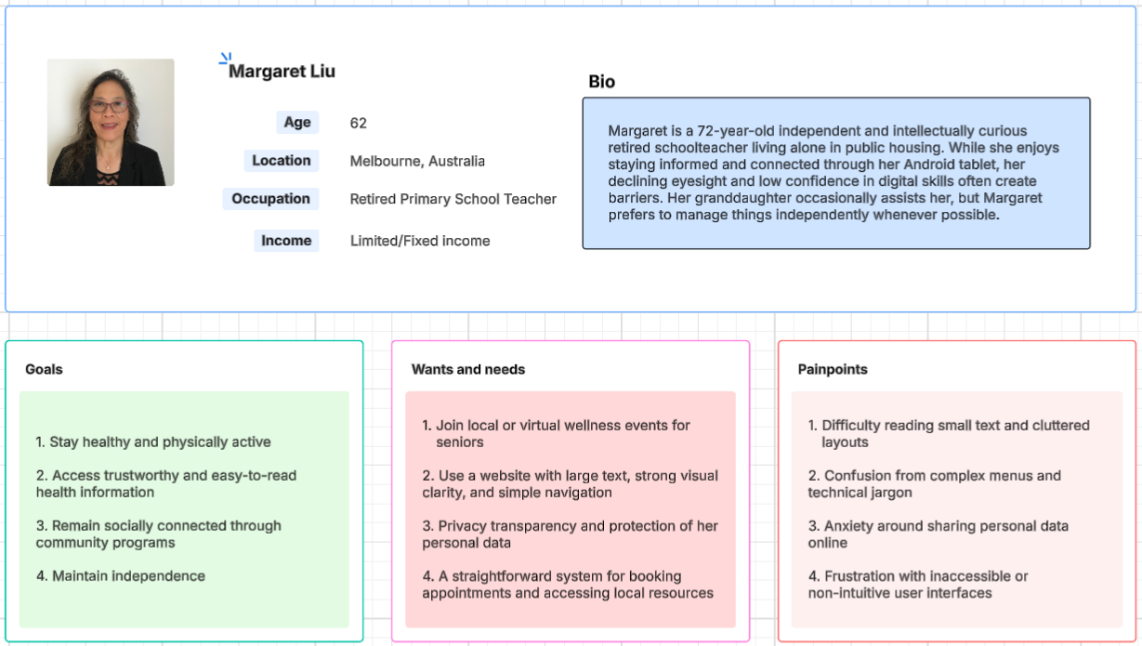

### User Persona 2: George Thompson

George Thompson is a 67-year-old retired electrician living in Brisbane with his wife, who was recently diagnosed with early-stage dementia. George is computer literate, particularly with desktops, but feels increasingly disconnected from modern mobile-first websites and applications. As a caregiver, he bears a lot of responsibility—not just managing his own health, but also helping his wife with daily tasks and navigating the healthcare system on her behalf.

George is actively looking for local support services, such as memory clinics, community caregiver programs, and mental health education. He also needs practical advice on managing dementia symptoms, diet, and stress. One of his key frustrations is wasting time on websites that don’t let him sort or filter results effectively. He often encounters pages filled with overwhelming medical jargon and long paragraphs that are difficult to skim. Because of his busy and emotionally demanding routine, he values anything that saves him time, improves clarity, or offers reassurance.

The web application meets George’s needs by providing a role-based portal for caregivers, with access to targeted tools and resources. The interactive table allows him to search by service type, rating, or distance—helping him find relevant programs more quickly. Articles and guides are written in clear, actionable formats, using icons, summaries, and optional video explanations. George can book appointments for himself or his wife and export information to PDF for offline reference. Automated email notifications ensure he doesn’t miss important events or sessions. He also appreciates the rating system, which lets him compare experiences shared by other users, offering a sense of trust and community.

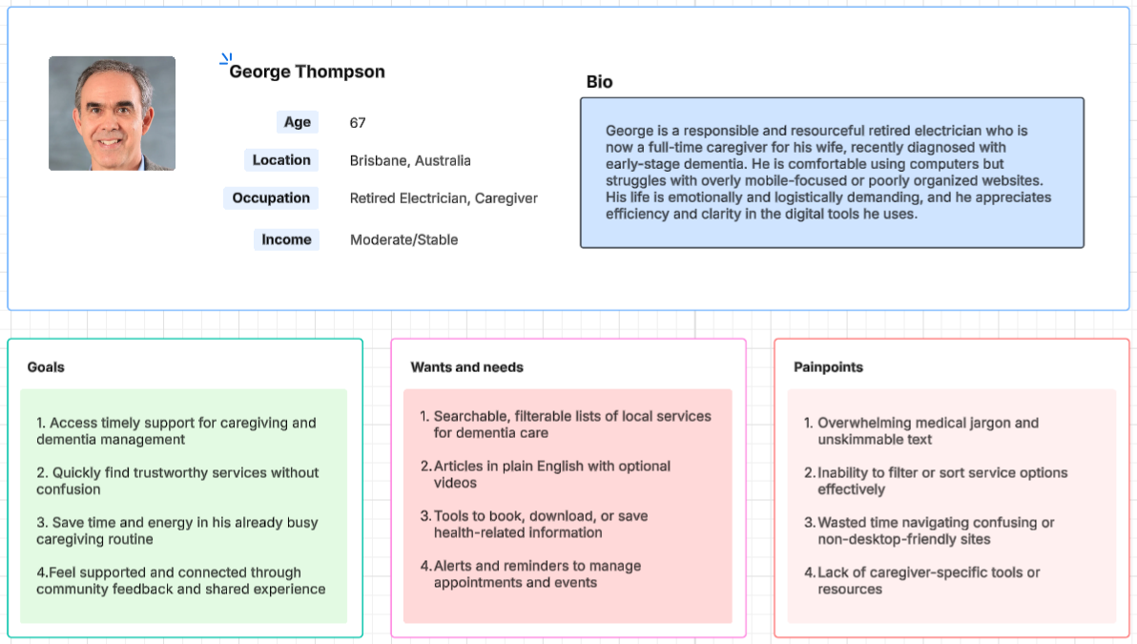

## Section 3: Sitemap

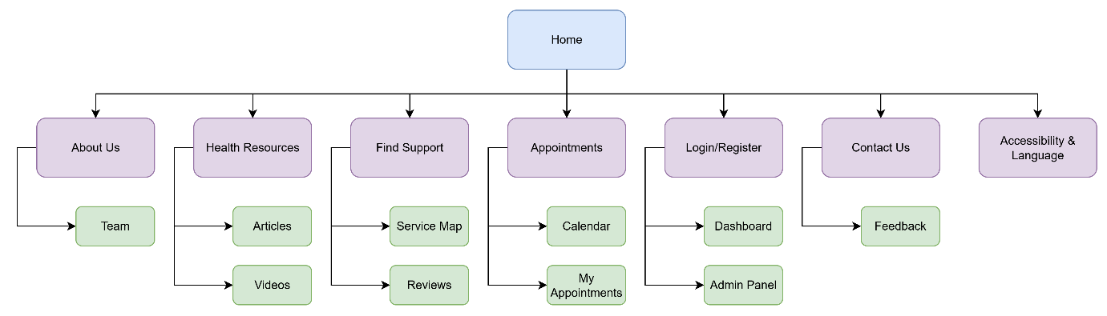

## Section 4: Wireframes/Low-fidelity prototype

### BR C.1

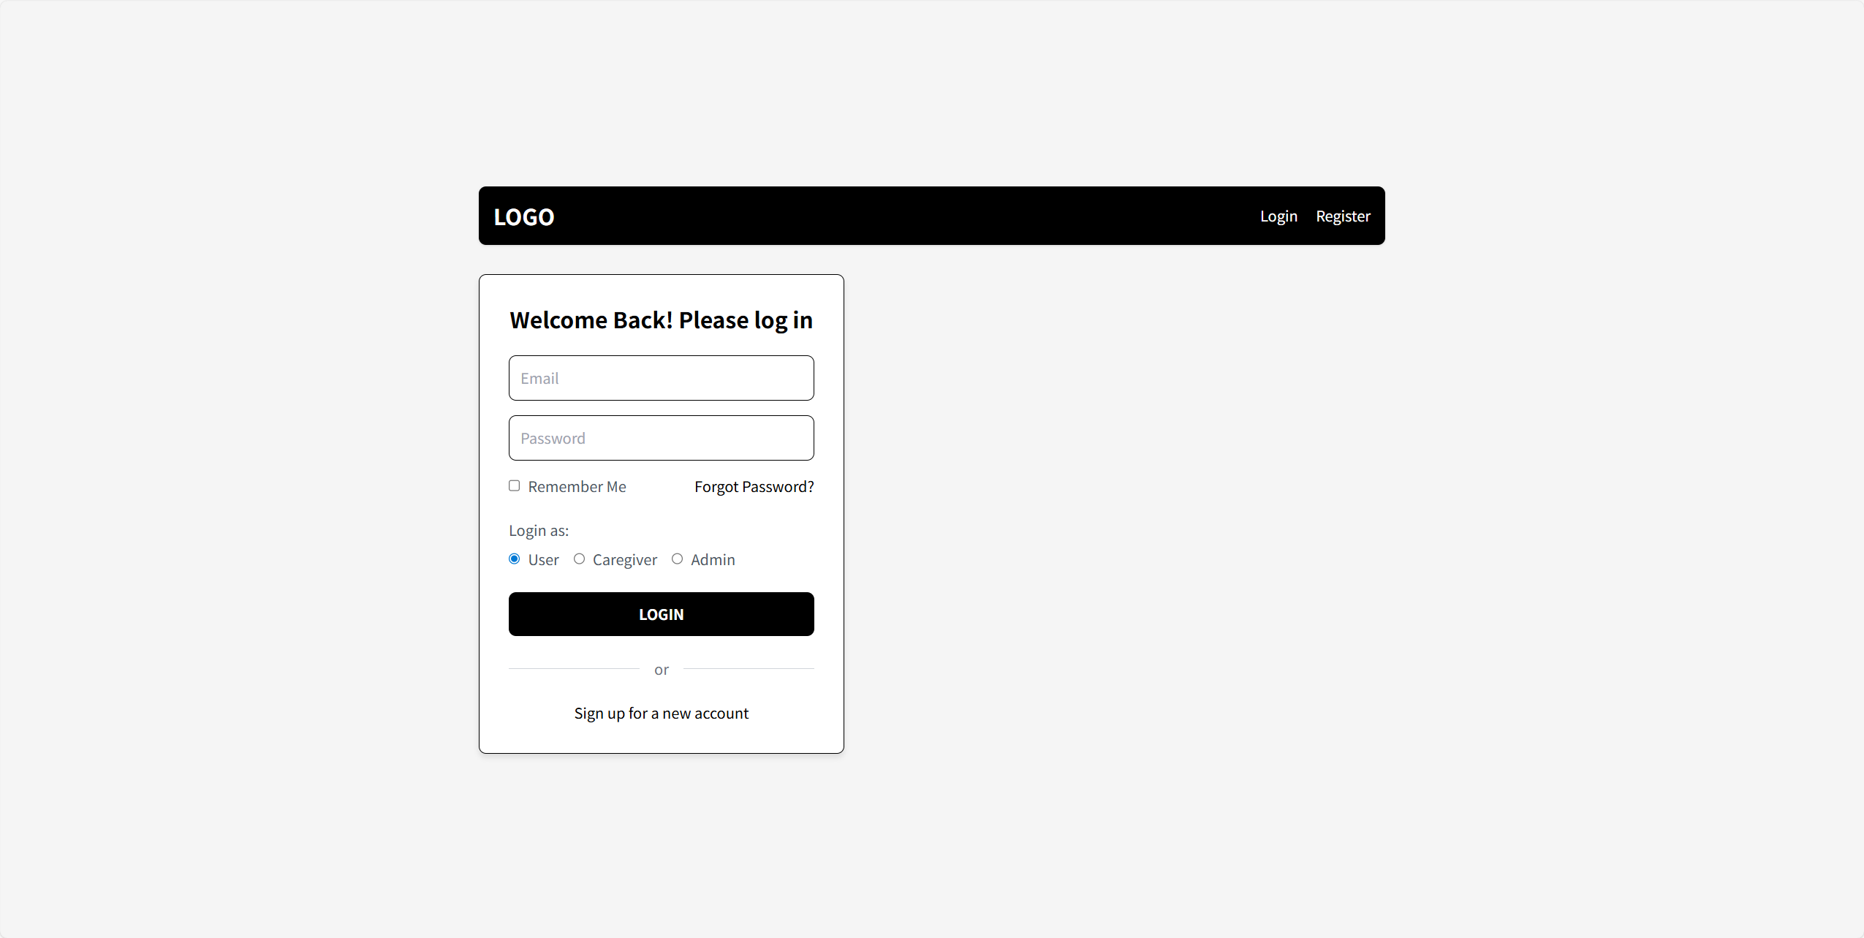

### BR C.3

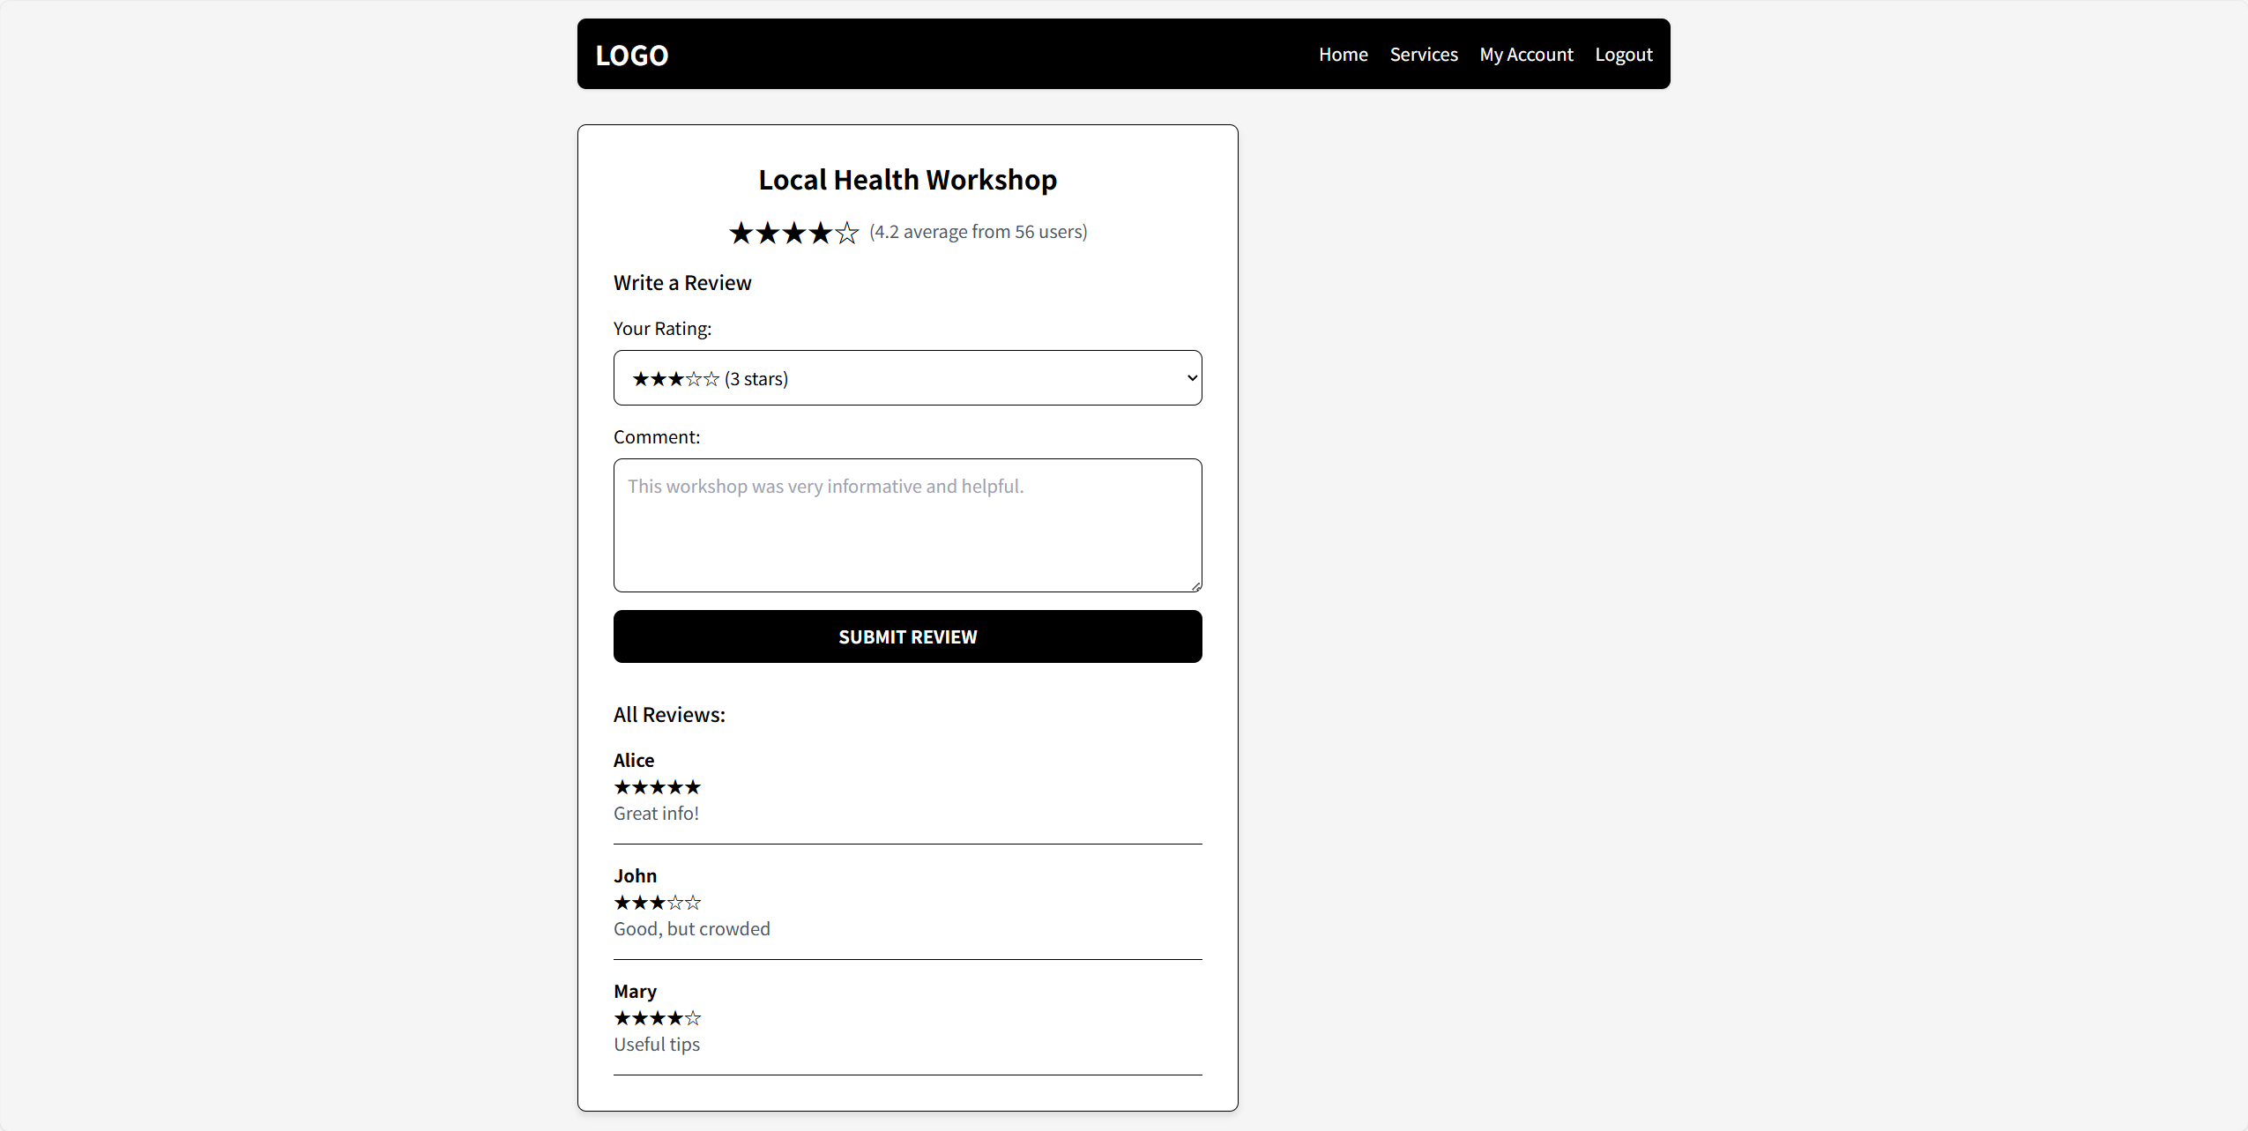

## Declaration: Additional Help

Any tools that you used (including Gen AI or existing code reuse) must be declared here.

**Note**: GenAI is not allowed for coding purposes in any assignment,

However, you may use GenAI for brainstorming and problem solving. You need to declare all such uses here. One row per help used.

|  |  |
| --- | --- |
| Name | Description |
| *Example: ChatGPT for brainstorming ideas* | *I used ChatGPT to brainstorm how to do X because I was feeling stuck with Y problem.* |
|  |  |